The High Commission of Canada February 26, 2024

One George St, #11-01

Singapore-049145

Subject: Invitation Letter

Dear Sir/Madam,

I am Bablul Khan, a Citizen of Canada, residing at 61 Trinnell Blvd, Scarborough ON M1L 1S6. My passport number is HN452775.

I invite my dear friend, Ahmed Al Mahir, Passport Number A03008861 to visit us in Canada. The purpose of his visit is social as well as tourism in Canada. We are excited to show him around our home in Canada, as well as help him explore the further reach of other provinces in Canada. During his stay in Toronto, I intend for him to stay with us and we will be taking care of all his accommodation and general expenses. You will also find a copy of my POA attached in this document.

I really appreciate your consideration on the matter of approving his visit visa. If you require any further information, you can contact me at my mobile phone # 647 574 0249.

Sincerely

Bablul Khan

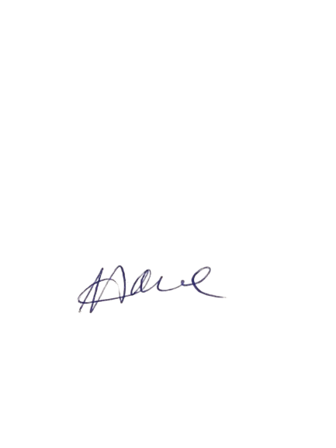Bablukhan34@gmail.com

